II B. Tech. II Semester Regular Examinations – May, 2023
design & analysis OF algorithms
Time: 150 Min (csE, CSE(CS)) Max. Marks:80M

SECTION – A
Answer all Four questions 4×10M=40M

- a) Define time complexity and Compute time complexity of T(n) in terms of θ for the following recurrence relation by using Substitution Method.
- Compare different asymptotic notations and Give the asymptotic notations (big O, big Ω and θ bounds) for the following function

- a) State Fractional Knapsack Problem.
b) Design an algorithm to find the optimal solution for Fractional Knapsack Problem to get maximum profit.
c) Find the optimal solution for given instance of Fractional Knapsack Problem for n=7, M=15, (p1, p2, p3, p4, p5, p6, p7) = (10, 5, 15, 7, 6, 18, 3) and (w1, w2, w3, w4, w5, w6, w7) = (2, 3, 5, 7, 1, 4, 1)
d) Analyze your algorithm and give the results in the order notation.

- a) Given a chain (A1, A2, ..., An) of n matrices, where matrix A_{i} (i = 1, 2, ..., n) has the dimension p_{i−1}×p_{i,} Find the optimal sequence of pairings for multiplication of matrices A1, A2...An for the sequence {4,2,3,1,3}
b) Find the number of scalar multiplications for the above product sequence.
c) Calculate the computation time to perform a sequence of multiplications from left to right.

- a) Define Backtracking. Design a backtracking algorithm for sum of subsets problem.
b) Construct a state space tree for m=10 and w = {2,3,5,6,8,10} to find the solution for sum of subsets using backtracking method and list the possible solutions.

c) What is the effect of backtracking on the time complexity of an algorithm? Do you think that backtracking is never required in a polynomial time algorithm?
SECTION - B
Answer all Two questions 2×20M=40M
- a) Define Optimal Binary Search Tree with scenario.
b) Design an algorithm to find the minimal cost of Optimal Binary Search Tree.
c) Construct an optimal binary search tree for n=4, the identifiers (a1, a2, a3, a4) = (do, if, int, while) and P[1:4] = (3,3,1,1) Q[0:4] = (2,3,1,1,1) by using tabulation method in dynamic programming.

- a) State P, NP and NP-Complete classes of problems.
b) State Travelling Sales person problem. Design an algorithm for travelling sales person problem to find the minimal path and calculate the minimal route for the cost matrix using Least Cost (LC) branch and bound method.
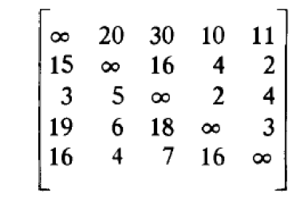
- Compute time complexity for the above problem (part b).

